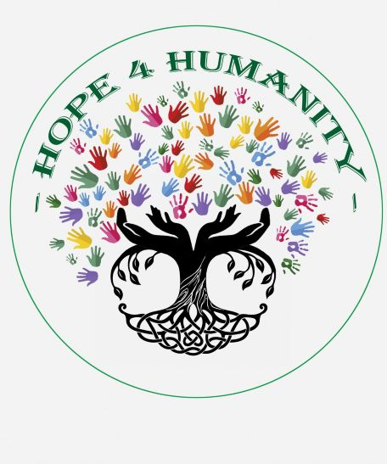

Migrant and Immigration Organizations
Support, Learn and Donate:

La Posada Providencia
30094 Marydale Road
San Benito, TX 78586
LPPShelter.org/WaystoGive
Or contact:
Magda Bolland, Executive Director
mbolland@lppshelter.org

Good Neighbor Settlement House
1254 E. Tyler Street
Brownsville, TX 78520
www.goodneighborsh.org

Catholic Charities Respite Center
Catholic Charities of the RGV
700N. Virgen de San Juan Blvd
San Juan, TX 78589
Payable to Catholic Charities of the RGV
In Memo line state: Humanitarian Respite Center
www.catholiccharitiesrgv.org

Justice for Our Neighbors
A United Methodist immigration ministry
You can give to Justice for Our Neighbors, UMCOR Advance #901285
Give online at: JFON Advance
or mail to:
JFON P & J Clinic,
PO Box 60053
Charlotte, NC 28260-053.
www.jfon

Tucson Samaritans
To save lives in the Southern Arizona Desert
http://www.tucsonsamaritans.org/

Humane Borders
Humane Borders, motivated by faith and the universal need for kindness, maintains a system of water stations in the Sonoran Desert on routes used by migrants making the perilous journey here on foot. Our primary mission is to save desperate people from a horrible death by dehydration and exposure and to create a just and humane environment in the borderlands. We locate our water stations on government and privately owned land with permission from the landowners.

PO Box 27024
Tucson, AZ 85726
Tel: (520)398-5053
https://humaneborders.org/

Border Community Alliance
Dedicated to the cultivation of cross-border awareness and positive international relations.

PO Box 1863
Tubac, AZ 85646
info@bordercommunityalliance.org
https://bordercommunityalliance.org/

Colibri Center for Human Rights
The Colibrí Center for Human Rights is a nonprofit, nongovernmental organization with the mission to end disappearance and uphold human dignity along the U.S.-Mexico border. Colibrí works in solidarity with the families of the disappeared to find truth and justice through forensic science, investigation, and community organizing. Colibrí bears witness to this unjust loss of life, accompanying families in their search and holding space for families to build community, share stories, and raise consciousness about this human rights crisis.

3849 E. Broadway Blvd, #206
Tucson, AZ 85716
Tel: 520-724-8644
https://www.colibricenter.org/

The Inn Project
A UMC Desert Southwest ministry for housing migrants who come to the US legally.
https://dscumc.org/?s=the+inn+project

End Operation Streamline
Operation Streamline is an initiative of the Department of Homeland Security and the Department of Justice launched in 2005 under a “zero-tolerance” policy to prosecute unauthorized immigrants as criminals. Streamline courts were created to deliver en masse fast-track criminal court proceedings.

https://endstreamline.org/what-is-operation-streamline/

NC Justice
www.ncjustice.org - The NC Justice Center provides legal assistance to North Carolinians with low incomes in carefully selected, high-impact cases that are designed to help alleviate poverty by protecting or expanding important rights for large numbers of vulnerable people. Targeted areas of law include consumer rights, housing, immigrant rights, access to health care, public education, and worker rights.
NC Refugee Assistance Program
www.ncdhhs.gov/assistance/refugee-services - The North Carolina Refugee Assistance Program (NC RAP) is a short-term transitional program that helps refugees and other eligible recipients become economically self-sufficient. Funding for this program comes from the Office of Refugee Resettlement within the US Department of Health and Human Services. NC RAP consists of two service areas: Refugee Public Assistance and Refugee Support Services.
US Committee for Refugees and Immigrants
https://www.immigrationadvocates.org - The U.S. Committee for Refugees and Immigrants, North Carolina Field Office (USCRI - NC) was established in 2007 to help refugees build new lives in North Carolina. Each year, USCRI - NC welcomes refugees who have fled violence and persecution from places like Burma, Cuba, Somalia, Sudan, and Vietnam. USCRI - NC works to bring hope and opportunity to the lives of refugees and immigrants by defending human rights, promoting self-sufficiency, and forging community partnerships. USCRI - NC focuses on meeting the immediate basic needs of new arrivals, assisting refugees in obtaining early employment and achieving self-sufficiency, and nurturing community integration for new Americans.
The North Carolina Council of Churches
https://www.ncchurches.org - The North Carolina Council of Churches was founded in 1935 and is a statewide ecumenical organization promoting Christian unity and working towards a more just society. The Council enables denominations, congregations, and people of faith to impact our state on issues such as economic justice and development, human well-being, equality, compassion and peace, following the example and mission of Jesus Christ.
Texas Impact
https://texasimpact.org - Texas Impacts – Courts & Ports Faithful Witness Program - 2-day immersion experience engages people of faith to witness first-hand the legal and law enforcement processes related to immigration in South Texas. program – brings small groups to the border to monitor
La Semilla
https://www.facebook.com/LaSemillaUMC/
is a new faith community that strives to be present in service with the Hispanic/Latinx community, along with the larger immigrant community in Durham, NC and its surrounding areas.

The Latin America Working Group
https://www.lawg.org/
The Latin America Working Group (LAWG) and its sister organization, the Latin America Working Group Education Fund (LAWGEF), mobilize concerned citizens, organizations, and networks to call for just U.S. policies towards Latin America and the Caribbean. We educate the public about the impact of U.S. foreign and immigration policy and advocate before the U.S. Congress and the executive branch. We work closely with civil society partners in Latin America to support their human rights campaigns and make sure their voices are heard in the policy debates that take place in Washington, D.C. but shape the lives of millions throughout the region.
The Rhizome Center
https://www.rhizomecenter.org/
The Rhizome Center for Migrants’ mission is to support and defend forcibly displaced persons and uprooted people at risk around the world. Through the help of technology and transborder networks, we combine direct services, advocacy, and socially-driven development to empower migrant communities.
No More Deaths
https://nomoredeaths.org/en/
The mission of No More Deaths is to end death and suffering in the Mexico–US borderlands through civil initiative: people of conscience working openly and in community to uphold fundamental human rights. Our work embraces the Faith-Based Principles for Immigration Reform and focuses on the following themes:
- Direct aid that extends the right to provide humanitarian assistance
- Witnessing and responding
- Consciousness raising
- Global movement building
- Encouraging humane immigration policy

Immigrant Legal Resource Center
https://www.ilrc.org/
The mission of the Immigrant Legal Resource Center (ILRC) is to work with and educate immigrants, community organizations, and the legal sector to continue to build a democratic society that values diversity and the rights of all people.
Church World Service
https://cwsglobal.org/
Church World Service was born in 1946, in the aftermath of World War II. Seventeen denominations came together to form an agency "to do in partnership what none of us could hope to do as well alone." The mission: Feed the hungry, clothe the naked, heal the sick, comfort the aged, shelter the homeless.

